**Page Replacement Algorithms**

* Want lowest page-fault rate.
* Evaluate algorithm by running it on a particular string of memory references (reference string) and computing the number of page faults and page replacements on that string.
* In all our examples, we use a few recurring reference strings.

**Graph of Page Faults vs. the Number of Frames**

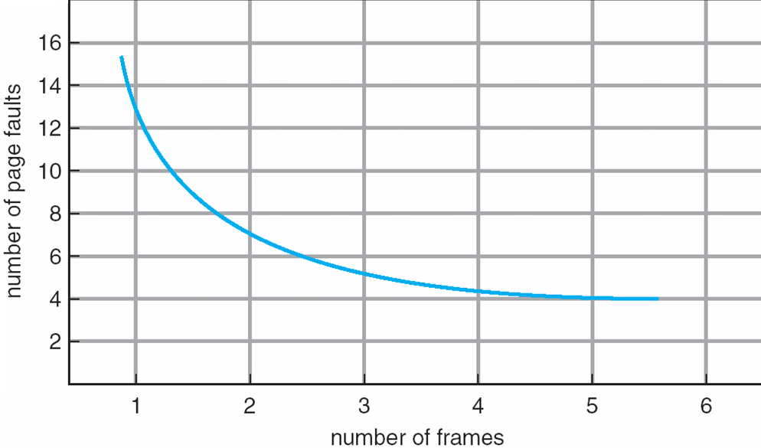

**The FIFO Policy**

* Treats page frames allocated to a process as a circular buffer:
  + When the buffer is full, the oldest page is replaced. Hence first-in, first-out:
    - A frequently used page is often the oldest, so it will be repeatedly paged out by FIFO.
  + Simple to implement:

requires only a pointer that circles through the page frames of the process

**FIFO Page Replacement**

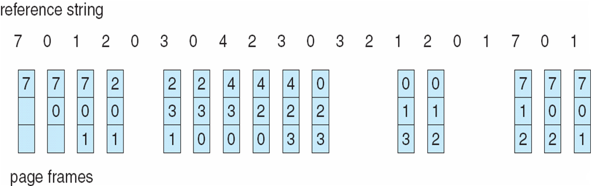

**Page fault=15.**

* The number of faults for four frame is greater than the number of faults for three frame. This most unexpected result is known as Belady’s Anomaly.
* We would expect that giving more memory to a process would improve its performance. Therefore these assumption was not always true. Belady’s Anomaly was discovered as a result.
* FIFO Replacement manifests Belady’s Anomaly:
  + more frames ⇒ more page faults

**FIFO Illustrating Belady’s Anomaly**

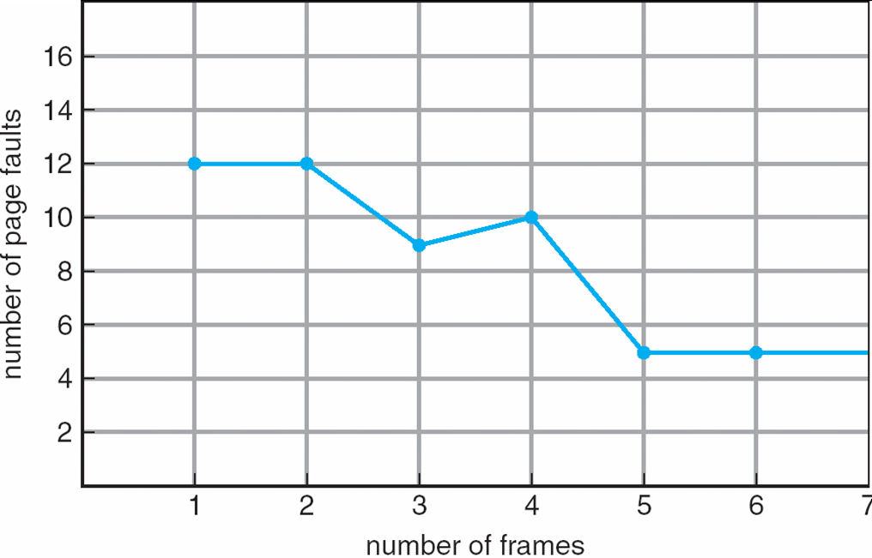

**OTHER’S REPLACEMENT ALGORITHM**

**Optimal Page Replacement**

* The Optimal policy selects for replacement the page that will not be used for longest period of time.
* Impossible to implement (need to know the future) but serves as a standard to compare with the other algorithms we shall study.

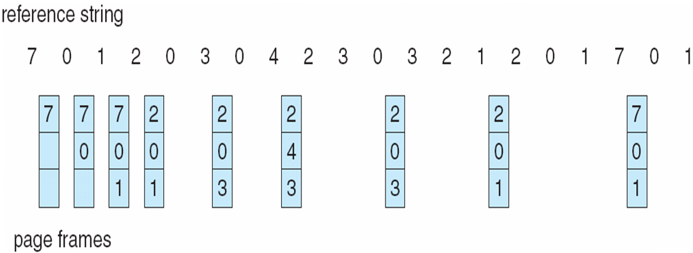

**LRU Page Replacement**

* Replaces the page that has not been referenced for the longest time:
  + By the principle of locality, this should be the page least likely to be referenced in the near future.
  + performs nearly as well as the optimal policy.

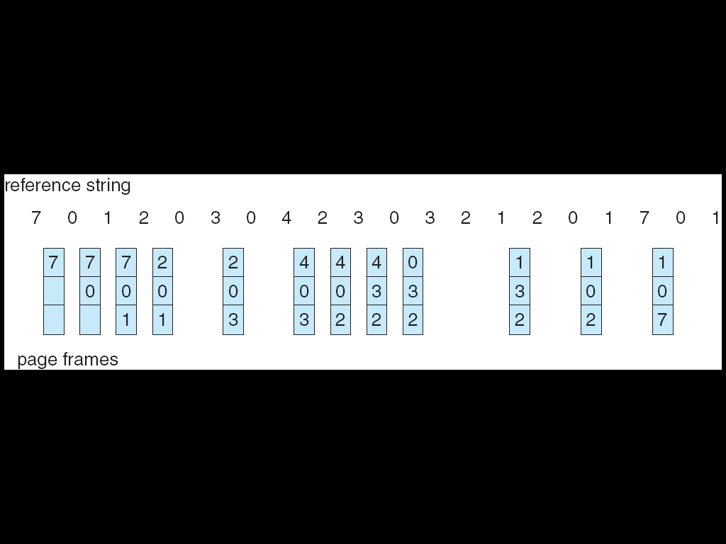

**LRU Approximation Algorithms (1)**

* Reference Bit:
  + With each page associate a bit, initially = 0
  + When page is referenced, bit is set to 1.
  + Replace the one which is 0 (if one exists) –   
    we do not know the real order of use, however**.**
* Reference Byte:
  + Idea is to record reference bits at regular intervals;   
    Keep a byte of reference bits for each page.
  + At regular intervals (say, every 20 ms), left shift   
    the reference bit of each page into the high-order   
    bit of the byte.
  + Each reference byte keeps the history of the page   
    use (aging) for the last eight time intervals.
  + If we interpret the reference byte as an unsigned integer, the page with the lowest number is the   
    LRU page.

**The Clock (Second Chance) Policy**

* The set of frames candidate for replacement is considered as a circular buffer.
* When a page is replaced, a pointer is set to point to the next frame in buffer.
* A reference bit for each frame is set to 1 whenever:
  + a page is first loaded into the frame.
  + the corresponding page is referenced.
* When it is time to replace a page, the first frame encountered with the reference bit set to 0 is replaced:
  + During the search for replacement, each reference bit   
    set to 1 is changed to 0.

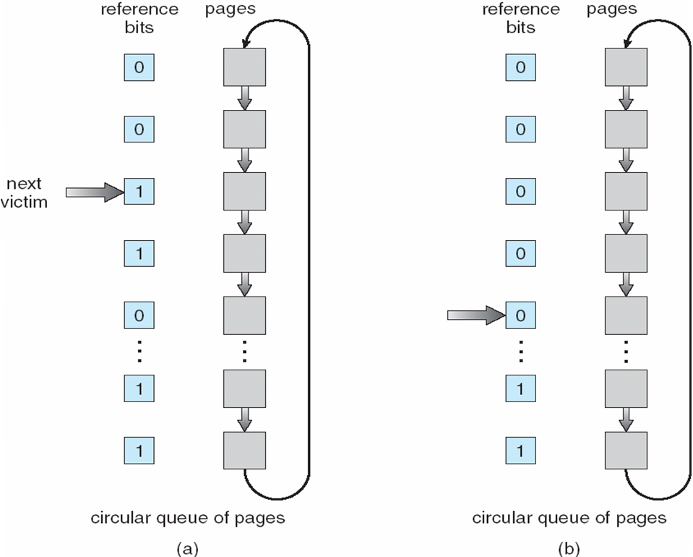

**Comparison of Clock with FIFO and LRU**



* Asterisk indicates that the corresponding use bit is set to 1.
* The arrow indicates the current position of the pointer.
* Note that the clock policy is adept at protecting frames 2 and 5 from replacement.
* Numerical experiments tend to show that performance of Clock is close to that of LRU.
* Experiments have been performed when the number of frames allocated to each process is fixed and when pages local to the page-fault process are considered for replacement:
  + When few (6 to 8) frames are allocated per process, there is almost a factor of 2 of page faults between LRU and FIFO.
  + This factor reduces close to 1 when several (more than 12) frames are allocated. (But then more main memory is needed to support the same level of multiprogramming).

**Fixed-Allocation, Local Page Replacement**

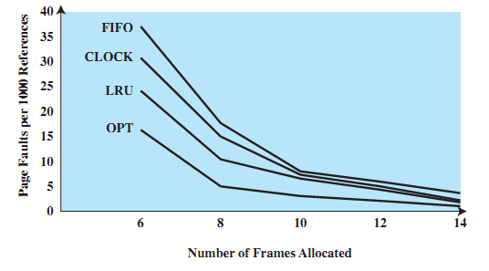

**Counting-based Algorithms**

* Keep a counter of the number of references that have been made to each page.
* Two possibilities: Least/Most Frequently Used (LFU/MFU).
* LFU Algorithm: replaces page with smallest count; others were and will be used more.
* MFU Algorithm: based on the argument that the page with the smallest count was probably just brought in and has yet to be used.

**Page Buffering**

* Pages to be replaced are kept in main memory for a while to guard against poorly performing replacement algorithms such as FIFO.
* Two lists of pointers are maintained: each entry points to a frame selected for replacement:
  + a free page list for frames that have not been modified since brought in (no need to swap out).
  + a modified page list for frames that have been modified (need to write them out).
* A frame to be replaced has a pointer added to the tail of one of the lists and the present bit is cleared in corresponding page table entry; but the page remains in the same memory frame.
* At each page fault the two lists are first examined to see if the needed page is still in main memory:
  + If it is, we just need to set the present bit in the corresponding page table entry (and remove the matching entry in the relevant page list).
  + If it is not, then the needed page is brought in, it is placed in the frame pointed by the head of the free frame list (overwriting the page that was there); the head of the free frame list is moved to the next entry.
  + (the frame number in the page table entry could be used to scan the two lists, or each list entry could contain the process id and page number of the occupied frame).
* The modified list also serves to write out modified pages in cluster (rather than individually).

**Implementation of the FIFO algorithm (using c)**

* For evaluation we take a particular string of memory references, called reference string.
* In FIFO page replacement algorithm-for each page we track the time when it was brought into the memory.
* And when any replacement request comes then oldest page is chosen.
* Using queue in our implementation is easier rather than tracking time of all pages
* If we are using queue in our implementation than
* Replacement of any page takes place at the head of the queue and.
* Insertion of pages takes place at the tail of the queue.
* Page fault is a interrupt that occurs when a program request page that is not in real memory. Then this interrupt sends signal to OS to fetch that page from virtual memory and load it into RAM.

**Program:**

#include<stdio.h>

int main()

{

int a[50],count=0,i,j,k,n,m;

printf(“\n\tEnter no. of pages:\n”);

printf(“\t”);

scanf(“%d”,&n);

printf(“\n\tEnter values of reference string:\n”);

for(i=0;i<n;i++)

{

printf(“\t”);

scanf(“%d”,&a[i]);

}

printf(“\n\tEnter no of frames:\n”);

{

printf(“\t”);

scanf(“%d”,&m);

}

int count1[m];

for(i=0;i<m;i++)

count1[i]=-1;

printf(“\nDisplaying Distribution------------------------\n”);

for(i=0;i<n;i++)

{

k=0;

for(j=0;j<m;j++)

{

if(a[i]==count1[j])

{

k++;

count--;

}

}

count++;

if(count<=m&&k==0)

{

count1[i]=a[i];

}

else if(k==0)

{

count1[(count-1)%m]=a[i];

}

printf(“\n\t****************************************************\n”);

for(j=0;j<m;j++)

{

printf(“\t”);

printf(“(%d)\t”,count1[j]);

}

}

printf(“\n\n\tTotal page faults %d”,count);

return 0;

}

**Out put:**

